FLIR ONE

The Flir ONE uses a 2 camera system:

* 1 thermal LEPTON camera:
  + <http://www.flir.com/cores/content/?id=66257>
  + Resolution: 160x120
  + Framerate: 8.7 Hz
  + Pixel size: 12µm
  + Spectral range: 8-14 µm

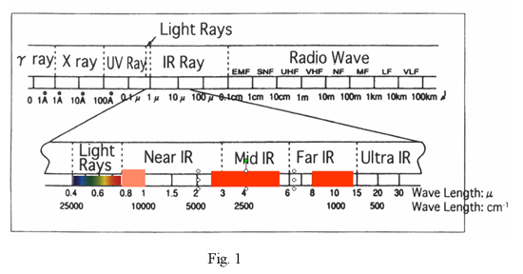

* + Vertical field of view: 46°
  + Horizontal field of view: 35°
  + Temperature range: -20°C to 120°C (-4°F to 248°F)
  + Temperature difference: 0.1°C (0.18°F)
  + Accuracy: ±5%, depends on many factors like ambient and scene temperature, emissivity of materials
* 1 visible light VGA camera:
  + Used to obtain visible edge data
  + 640x480 resolution
  + Obviously requires light (unlike the thermal sensor)

The images taken by each camera get combined with FLIR’s proprietary and patented MSX (Multi Spectral Dynamic Imaging) technology. <http://www.flir.co.uk/cs/display/?id=56012>

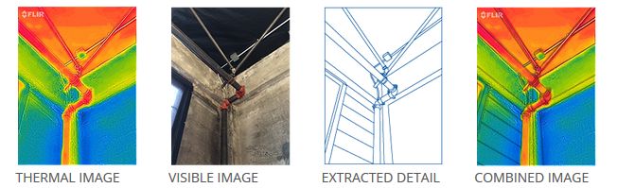

Testing: all done with the app provided by FLIR

<https://play.google.com/store/apps/details?id=com.flir.flirone&hl=en_GB>

MSX: full images in folder MSX_testing

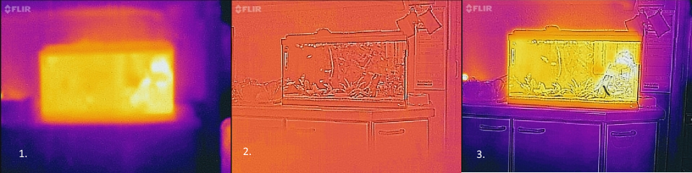

1. Image with covered VGA camera
2. Image with covered thermal sensor
3. Combined image from VGA camera and thermal sensor

Distance testing: pot of hot water (12cm height, Ø 21.5cm), ambient temperature: -7°C

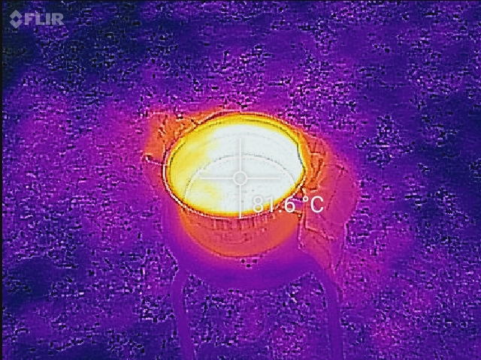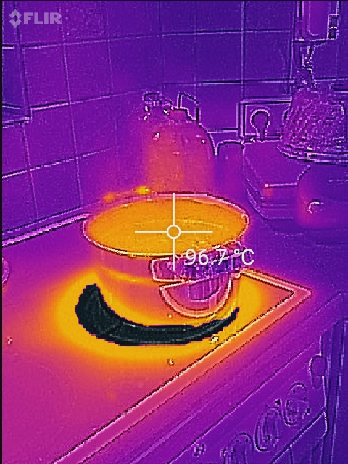

Close up

distance: ∼ 6m

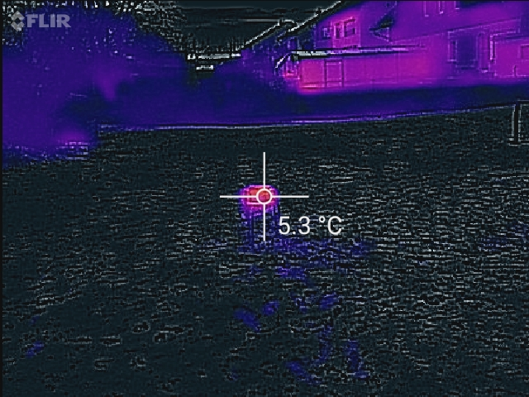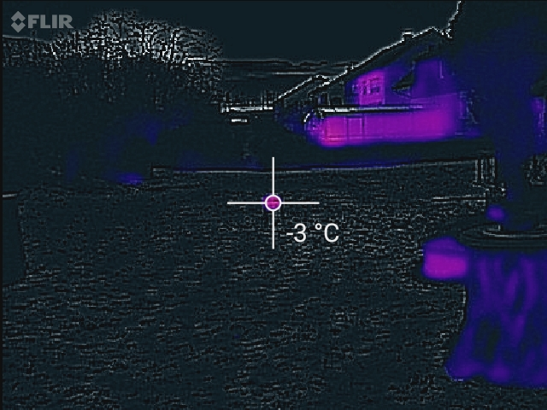

distance: ∼ 12m

distance: ∼ 25m, full images in folder distance_testing_pot

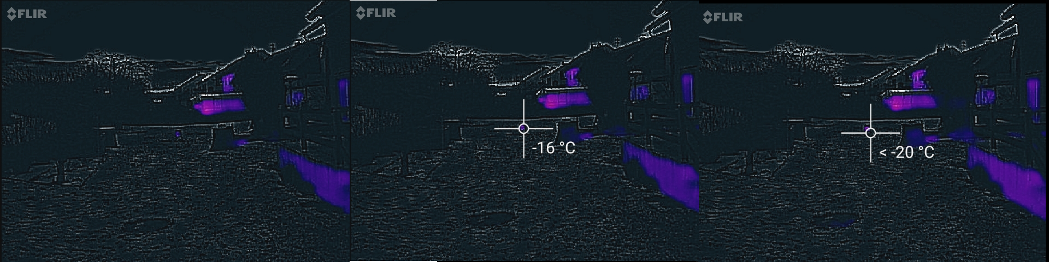

1. Original image
2. Measured temperature of pot
3. Measured temperature of area around pot

Distance testing: Human heat signature, ambient temperature: -7°C

full images in folder distance_testing_humanheatsignature

FLIR states on their website human heat signatures are measurable up to ∼ 100 feet (equals 30.48m)

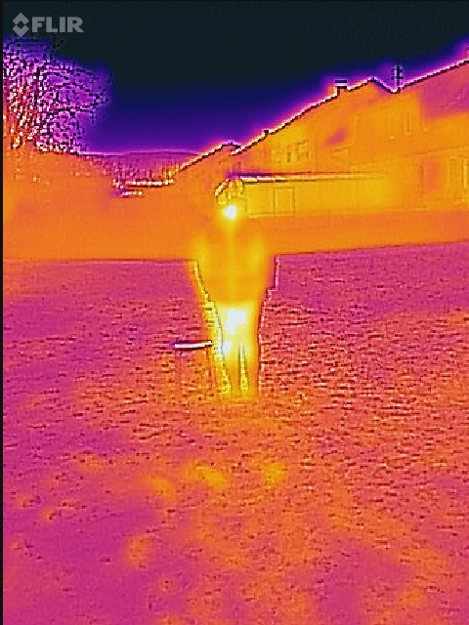

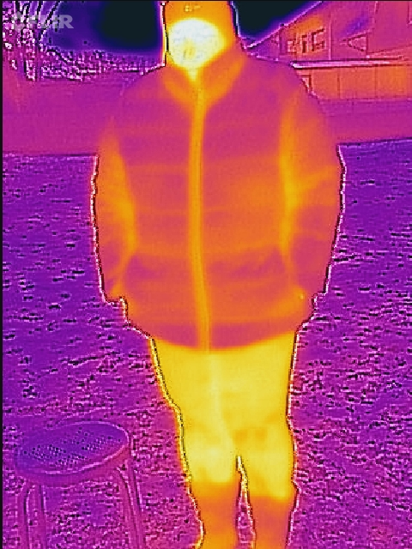

1. Close up 2. distance: ∼ 6m

3. distance: ∼ 12m 4. distance: ∼ 25m

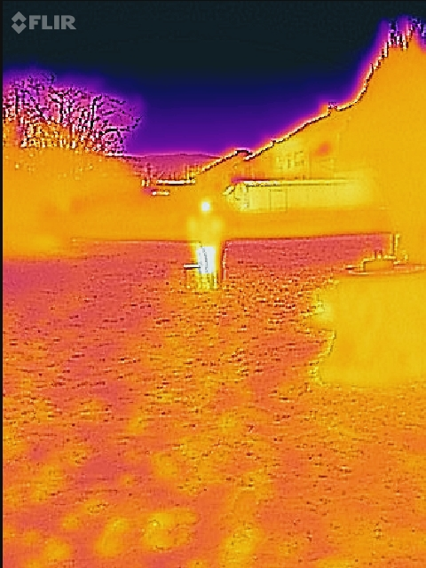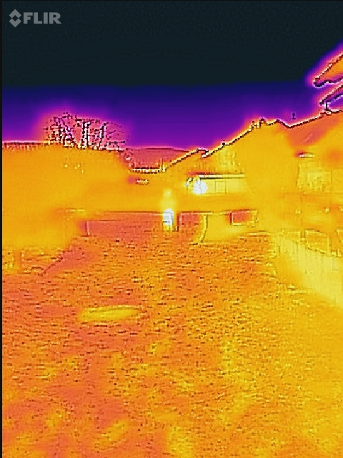

1. distance: ∼ 30m

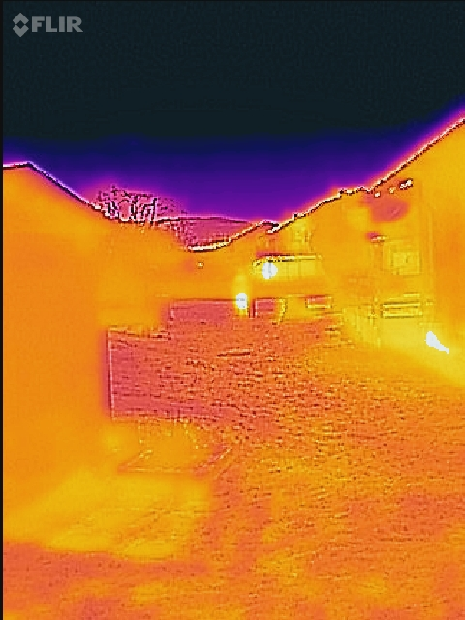

Other testing:

heat signature after sitting on a couch

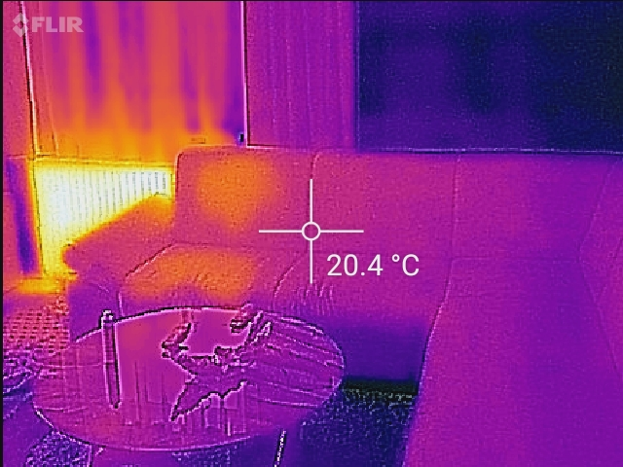

heat signature on glass

